Chip back potential is the level which bulk silicon is maintained by on-chip connection, or it is the level to which the chip back must be connected when specifically stated below. If no potential is given the chip back should be isolated.

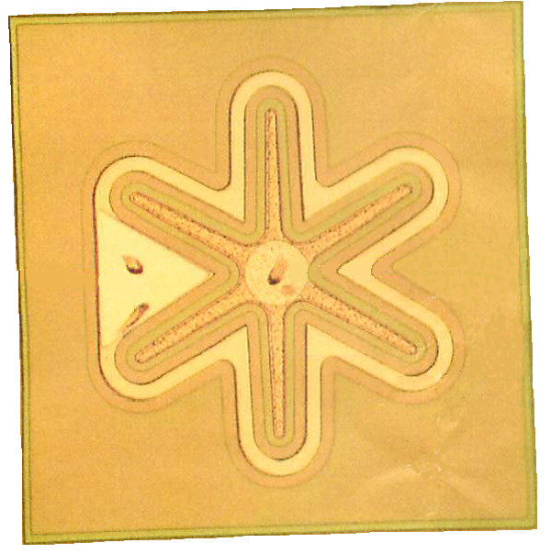
EMITTER
BASE

Top Material: Al
Backside Material: Au
Emitter: .004” X .004”
Base: .008” X .008”
Backside Potential: COLLECTOR

APPROVED BY: DK DIE SIZE .036” X .036” DATE: 10/4/21
MFG: MOTOROLA THICKNESS .006” P/N: 2N3499
DG 10.1.2

Rev B, 7/19/02

